Change in pH on Adding Acid or Base to a Buffer
Troy University Chemistry Faculty
Licensed under a Creative Commons Attribution-ShareAlike 4.0 International License.

Need to Know for This Lab:
Know the dilution equation.
Know how to calculate the number of moles, given molarity and a volume in mL.

Introduction
A buffer is a solution that resists change in pH when acid or base is added. That is, if acid or base is added to a buffered solution, the pH only changes slightly. (A buffered solution also resists change in pH when it is diluted.)
A buffer consists of a weak acid and its conjugate base. To understand how a buffer works, consider the dissociation of a weak acid, represented as HA:
HA(aq) + H₂O(l) ⇌ H₃O⁺(aq) + A–(aq) Eq (1)
acid conjugate base
Suppose a buffer is prepared by dissolving both HA and A– in a beaker containing water. (The A– is typically added as a salt, e.g., NaA.) To this buffer solution is added the strong acid, HCl, which dissociates to form H⁺(aq) and Cl–(aq). The H⁺(aq) from the strong acid then reacts with the A–(aq) from the buffer, forming HA(aq), which is a weak acid.
A–(aq) + H⁺(aq) ⇌ HA(aq) Eq (2)
So, the strong acid HCl is converted to the weak acid, HA. And, since weak acids dissociate less than strong acids, the solution is less acidic than it would be without the A– present.
Likewise, if the strong base, NaOH, is added to the buffer solution, the hydroxide (OH–) reacts with the HA(aq) from the buffer to form A–(aq), which is a weak base.
HA(aq) + OH–(aq) ⇌ A–(aq) + H₂O(l) Eq (3)
So, the strong base NaOH is converted to the weak base, A–(aq). And, since weak bases produce less hydroxide ion than strong bases do, the solution will be less basic than it would be without the HA present.
A–(aq) + H₂O(l) ⇌ OH–(aq) + HA(aq) Eq (4)
The pH of a buffer is determined by the molarity ratio of the weak acid and its conjugate base, and can be calculated by the Henderson-Hasselbalch equation:
$pH=pK_{a}+log\left(\frac{[A^{-}]}{[HA]}\right)$ Eq (5)
where K_{a} is the dissociation constant of the weak acid.
In this lab, the resistance of a buffer to change in pH will be demonstrated by measuring the pH of two sets of solutions: one set will be prepared by adding acid and base to water; the other set by adding acid and base to a buffer.

Procedure

Calibration of the pH meter
- Obtain standardization buffers. Obtain two 50 mL beakers. Fill one half-full with the pink pH 4 standardization buffer (in a bottle, probably located on the side table), and fill the other one half-full with the blue pH 10 standardization buffer. Also, obtain a 100 mL beaker to hold waste rinse water.
- Start LoggerPro. Plug the pH electrode USB cable into the computer. Start the LoggerPro software by double clicking on the icon.
The tip of the pH electrode contains a glass bulb that produces a tiny voltage that is inversely proportional to the pH of the solution. This glass tip has to be kept wet, so it is stored in a buffer solution. If the glass tip dries out, it stops responding to pH until it is rehydrated by soaking in a buffer solution overnight. The glass tip should not be touched so that oil from the fingers does not contaminate the glass. The glass tip is very fragile, so it is protected by a plastic guard tip that should not be removed. PLEASE BE VERY CAREFUL!
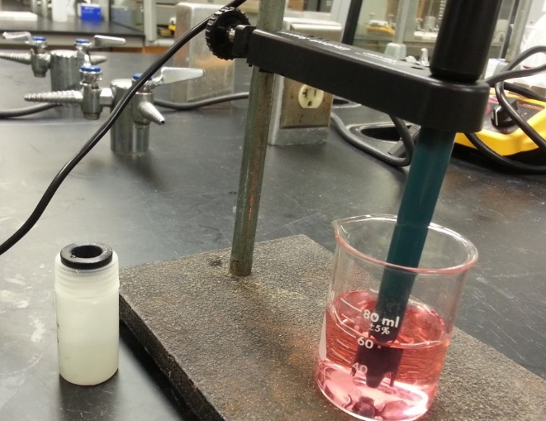
- Setting up the pH electrode. The pH electrode is held in a plastic “electrode holder” that is attached to a ring stand. The electrode should be in the storage bottle. Loosen the lid and pull it and the bottle down to remove them from the electrode. When you pull the bottle lid off of the electrode, try to leave the plastic guard tip attached to the electrode. Leave the pH electrode in the electrode holder that is attached to a ring stand (leaving it in the holder frees up a hand). Lift the electrode up (it slides freely in the electrode holder) and place the empty waste rinse water beaker under the electrode. Lower the electrode into the beaker. Adjust the electrode holder on the ring stand so that the tip of the electrode is close to but not touching the bottom of the beaker. After that, leave the electrode holder firmly attached to the ring stand; to raise the electrode, just lift it up in the holder.
Figure 1. pH electrode in a solution. The electrode holder frees the hands.
- Place the electrode in first buffer solution. Lift the electrode up an inch or two, and rinse its tip with deionized water (the waste rinse water beaker collects this water). Blot the electrode dry with a lab tissue. (That way, the extra liquid won’t dilute or contaminate the solution being examined.) Place the electrode in the pH 4 buffer. (No need to move the electrode holder!) LoggerPro should display the pH at the lower left corner of the screen. The pH won’t be very close to 4.0 until after the electrode is calibrated. Wait for the pH reading to stabilize. Swirling the beaker in a circle seems to help stabilize the reading.
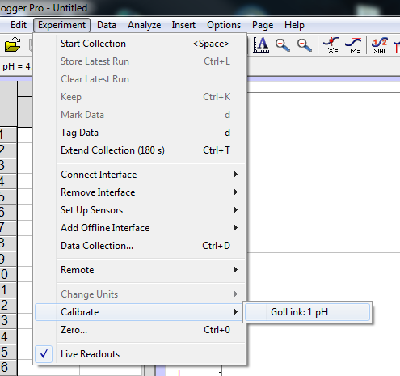
- Calibrate with the pH 4 buffer. Click “Experiment” >>> “Calibrate” >>> “Go!Link: 1 pH” as shown in the following figure. A window will pop up. In the pop-up window, shown below, click the “Calibrate Now” button. Then, enter “4.0” in the blank below “Reading 1”, and click the “Keep” button below it.
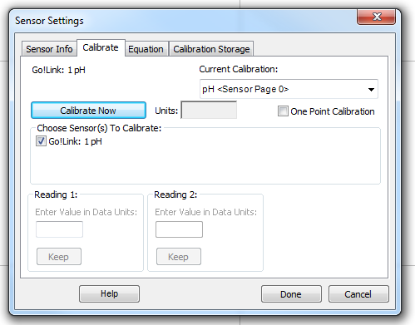
- Calibrate with the pH 10 buffer. Rinse the tip of the pH electrode with deionized water, dry it with a lab tissue, and place the electrode in the pH 10 buffer. The pH will not update, but the voltage will display in the dialog box. Swirl the beaker in a circle until the voltage reading stops changing. Then, enter “10.0” in the blank below “Reading 2”, and click the “Keep” button below it. Click the “Done” button. Now, you’ve finished the calibration of the pH electrode. Typically, a pH electrode only needs to be calibrated every few hours, which means the calibration you just did will be good for the whole lab.

Prepare a buffer solution
- Label a 250 mL Erlenmeyer flask as “buffer stock solution”.
- Using a clean 10 mL graduated cylinder, transfer 10.0 mL of the 1.0 M acetic acid stock solution to the buffer flask. Rinse the graduated cylinder after use.
- Using a clean 100 mL graduated cylinder, transfer 50.0 mL of the 0.20 M sodium acetate stock solution to the buffer flask. Thoroughly rinse the graduated cylinder after use.
- Using the rinsed 100 mL graduated cylinder, transfer 40.0 mL of deionized water into the buffer flask, making the total volume of the buffer 100 mL.
A fine point: because the buffer is made from three solutions (10 mL, 50 mL, and 40 mL) having different concentrations, the final volume of the buffer will be very slightly different from the sum of the volumes of its component solutions. But the difference is typically small and is negligible in this lab. Therefore, the total volume of the buffer you just made is assumed to be 100 mL.
- Mix the solution by swirling the flask (the shape of Erlenmeyer flasks makes them easy to swirl without spilling).
- Using the dilution equation, calculate the molarity of acetic acid in this buffer, and record this on the data sheet under “Buffer Composition”. Likewise, calculate and record the molarity of sodium acetate in the buffer.

Prepare acid and base solutions
- Prepare 0.10 M HCl. Label a 250 mL Erlenmeyer flask as “0.10 M HCl”. Using a clean 25 mL graduated cylinder, transfer 21.0 mL of 1.0 M HCl stock solution into the HCl flask. Thoroughly rinse the graduated cylinder after use. Using that rinsed 100 mL graduated cylinder, transfer 100 mL of deionized water into the flask, then add an additional 89 mL of deionized water. Carefully swirl the solution to mix it. The total volume of 0.10 M HCl is now approximately 210 mL. Record the molarity of this solution (0.10 M) on the data sheet below “Effect of adding acid to a buffer”.
- Prepare 0.10 M NaOH. Label another 250 mL Erlenmeyer flask as “0.10 M NaOH”. Make this solution using 21.0 mL of 1.0 M NaOH stock solution, and 189 mL of deionized water (this solution is make like the previous solution was made). Record the molarity of this solution (0.10 M) on the data sheet below “Effect of adding base to a buffer”.

Effect of adding acid to a buffer
- Prepare starting water and buffer solutions. Obtain two clean 250 mL beakers. Label one beaker “water”, and, using a clean 50 mL graduated cylinder, transfer 50.0 mL of deionized water into it. Label the other beaker “buffer”, and, using the 50 mL graduated cylinder, transfer 50.0 mL of the stock buffer solution into it. Thoroughly rinse the graduated cylinder after use.
- Add indicators. Add 5 drops of 0.03% methyl orange indicator solution and 5 drops of 0.1% malachite green indicator solution to each beaker. (Yes, two indicators in each solution.)
- Measure the pH. Use the pH meter to measure the pH of the solution in the “buffer” beaker. Record the pH on Data Sheet 1 in the “pH meter reading, buffer” column. Rinse the pH electrode with deionized water into the waste rinse water beaker and blot the electrode dry. Then, measure the pH of the solution in the “water” beaker. Record that pH on the Data Sheet in the “pH meter reading, water” column.
- Solution color. Record the color of each solution on the Data Sheet in the “Solution Color” columns.
- Effect of adding HCl. Using a clean 10 mL graduated cylinder, transfer 5.0 mL of your “0.10 M HCl” solution into the “water” beaker, and 5.0 mL into the “buffer” beaker. Mix the solutions well. Measure and record the pH of each solution, rinsing the electrodes between measurements. Also record the solution color.
- Effect of adding more HCl. Repeat the previous step for the following 0.10 M HCl solution additions: 5.0 mL (for a second addition), 10 mL, 30 mL and 50 mL. Use a 50 mL graduated cylinder for the last two additions.
- Clean up. When finished, discard the contents of the “buffer”, “water”, and “waste rinse water” beakers into the waste container in the front fume hood. Rinse the “buffer” and “water” beakers with tap water, then, with deionized water. Dry the two beakers for reuse in the next section.
Do NOT discard the solutions in the Erlenmeyer flasks. Those solutions will be used in the next section.

Effect of adding base to a buffer
- Prepare starting water and buffer solutions. Repeat step 1 in the previous section.
- Add indicators. Add 4 drops of methyl purple and 2 drops of 1% phenolphthalein to each solution.
- Measure the pH. Measure the pH of each solution as was done in step 3 in the previous section. Record all data on data sheet in the “Effect of adding base to a buffer” section.
- Solution color. Record the color of each solution.
- Effect of adding NaOH. Repeat step 5 in the previous section, except use 0.10 M NaOH, instead of 0.10 M HCl.
- Effect of adding more NaOH. Repeat step 6 in the previous section, except use NaOH instead of HCl.
- Clean up. Leave the buffer solutions on the desktop, unless this is the last section of the day. Discard all other solutions into the waste container in the front fume hood.

Calculations

Effect of adding acid to a buffer
Note: the shaded boxes do not need to be filled in.
- Fill in the column “Total mL HCl added”. This number is the sum of the amounts previously added, plus the amount added in the current run, given in the first column.
- Fill in the column “Total mL of solution”. To the initial volume in a beaker, 50 mL, add the total mL of HCl added. This is the total volume of the solution in the “water” beaker. (As can be seen, the buffer gets more dilute as the acid additions are made.)
- The K_{a} of acetic acid is 1.74 × 10⁻⁵. Calculate the pK_{a}, which is the negative log of K_{a}: pK_{a} = –log(K_{a}). Enter this value below the first table on the data sheet.
- The column, “Moles remaining in buffer”, gives how many moles of HA and A– remain after adding HCl. However, the first row is before any HCl is added, so this is the initial number of moles of each component in the buffer. Use the molarity of HA (acetic acid) that you previously wrote on the top of the data sheet to calculate how many moles of HA are in the 50 mL of buffer. Likewise, calculate how many moles of A– are in the 50 mL of buffer (the buffer contains both HA and A–). The other rows are filled in later.
- Calculate the pH expected of the buffer initially (before any HCl was added). The pH expected for a buffer is given by the Henderson-Hasselbalch equation, $pH=pK_{a}+log\left(\frac{\left[A^{-}\right]}{\left[HA\right]}\right)$. In the last two steps you calculated the value of pK_{a} for acetic acid, and the number of moles of A– and HA in the buffer solution. To get concentrations, divided the moles of A– and HA by the total volume of the buffer solution (50 mL) converted to liters. Your expected pH should be somewhat close to the pH that was actually measured.
Shortcut: for buffer problems, both HA and A– are in the same solution, so they have the same volumes, which cancel in the Henderson-Hasselbalch equation. The ratio of concentration in that equation can be written as $\left(\frac{\left[A^{-}\right]}{\left[HA\right]}\right)=\left(\frac{\frac{mol A^{-}}{L buffer}}{\frac{mol HA}{L buffer}}\right)=\left(\frac{mol A^{-}}{mol HA}\right)$. So, the mole ratio can be used instead of the concentration ratio.
Now that you’ve calculated the expected pH, check to see if it is anywhere close to your measured pH!
- Calculate the pH expected of the water initially (before any HCl was added). (Hint: what is the pH of neutral water?)

Row 4 calculations:
- Calculate the molarity of H⁺ in the water beaker from the observed pH using the following: [H⁺] = 10^{(-pH)}.
- Calculate the “Moles H⁺ added”. Calculate this value using the volume in the “total mL HCl added” column, and the “molarity of HCl solution that was prepared” previously recorded above the table.
- The column, “Moles remaining”, gives how many moles of HA and A– remain after adding HCl. The moles of HA that are present was increased by the number of moles of H⁺ that were added, because the HCl converts the A– to HA.
H⁺(aq) + A–(aq) → HA(aq)
Therefore, to the moles of HA initially in the buffer add the moles of HCl (i.e., H⁺) transferred to the buffer beaker. Similarly, from the moles of A– initially in the buffer, subtract the moles of HCl added.
- Using the Henderson-Hasselbalch equation and the moles found in the previous step, calculate the expected pH of the buffer solution
- Calculate the expected pH of the solution in the “water” beaker. First, calculate the molarity: divide the “moles H⁺ added” by the “total mL of solution” (in liters). Second, convert to pH: pH = –log[H+]

Last row calculations:
- Calculate the molarity of H⁺ in the water beaker as in step 7.
- Calculate the “Moles H⁺ added” as in step 8. Notice that this number of moles is greater than the number of moles of A– initially present in the buffer, so every bit of the initial A– is converted to HA. Enter the number of moles of A– remaining (0), and the number of moles of HA remaining.
- Calculate the pH of the “buffer” solution. This is not really a buffer solution any longer, because all of the A– has been used up. First, calculate how many moles of H⁺ remain by subtracting the initial moles of A– from the moles of H⁺ added. Second, calculate the concentration of H⁺ by dividing this number by the “total mL of solution mL”. Finally, calculate the pH using pH = -log([H⁺]).
- Calculate the expected pH of the solution in the “water” beaker as in step 11.

Effect of adding base to a buffer
- The first row (“0 mL HCl added”) of the previous table and the first row (“0 mL NaOH added”) of the table in this section have the same calculated values (because they both refer to the solutions before anything was added to them), so copy the values in the first row from the previous table to the table in this section. Also, the two columns, “Total mL NaOH added”, and “Total mL of solution”, are calculated using the same values as were used in the previous table to calculate “Total mL HCl added”, and “Total mL of solution”, so copy the values in those two columns to the analogous columns in this table.

Row 4 calculations:
- Calculate the molarity of OH– in the water beaker from the observed pH in two steps. First, convert from pH to pOH using the following: pH + pOH = 14. Second, calculate [OH–] using the following: [OH–] = 10^{(-pOH)}.
- Fill in the column “Moles OH–added”. Calculate this value using the volume in the “total mL NaOH added” column, and the “molarity of NaOH solution that was prepared” previously recorded above the table.
- The column, “Moles remaining”, gives how many moles of HA and A– remain after adding OH–. The moles of HA that are present are decreased by the number of moles of NaOH that are added, because the OH– converts the HA that is present to A–:
OH–(aq) + HA(aq) → A–(aq) + H₂O(l)
Therefore, from the moles of HA initially in the buffer, subtract the moles of NaOH transferred to the buffer beaker. Similarly, to the moles of A– initially in the buffer, add the moles of NaOH added.
- Using the Henderson-Hasselbalch equation and the moles found in the previous step, calculate the expected pH of the buffer solution
- Calculate the expected pH of the solution in the “water” beaker. First, calculate the molarity of OH–: divide the “moles OH- added” by the “total mL of solution” (in liters). Second, convert to pOH: pOH = –log[OH–]. Third, convert from pOH to pH using pH + pOH = 14. (Yes, a lot of new formulas for you to use here.)

